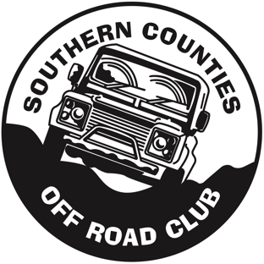
Southern Counties Off Road Club
Social Media Statement

Version | Author | Revision date | Summary of Changes | Date endorsed by  The Club  Committee
V 0.1 | M Chanter-Button | 29/11/23

This policy will be reviewed annually or when there is a legislative change or review
due to lessons learnt or best practice guidance
Southern Counties off Road Club Social Media Policy
Our statement
Southern Counties Off Road Club recognises that many children and young people today are fully engaged in a fast-moving and ever-changing technologically advanced world. Most children have access to computers and smartphones either in school and/or at home. In addition, the increasing use of smartphone technology with access to the mobile internet means that there are few restrictions on when and where children have access to social media sites. Southern Counties Off Road Club is committed to safeguarding the welfare of children and young people who engage with our club on any social media sites and as a result we have adopted the Social Media policy developed by Motorsport UK to support us in this commitment.

Our Policy
The full policy can be found here and includes a statement on the responsibility of Motorsport UK’s Communication Manager, the target age for these policies in line with government guidance that children under that age of 13 years old are not permitted to join social networking sites and further details for staying safe online, including resources from the Child Exploitation and Online Protection Centre. The full policy also includes a comprehensive list of Do’s and Don’ts for Parents and Carers, Staff and Volunteers and children/young people under the age of 18. The final section of the policy also includes details regarding youth produced sexual imagery or “sexting” as it sometimes referred to.

Useful Resources
Child Exploitation and Online Protection Centre (CEOP) www.ceop.police.uk

Tel: 0870 000 3344 or 0370 496 7622 www.thinkuknow.co.uk

CEOP provides a 24/7 single point of contact for law enforcement, industry, non-government organisations and the public for reporting instances of online child abuse or potential online abuse in the UK.

